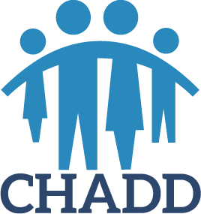

Kitsap CHADD
Support and Information for Parents, AD/HD Adults, Educators and Health Care Professionals
September 2020 – June 2021 Schedule

Thank you, Dr. Brian and Kerry Miller for starting this CHADD support group in 1993, OVER 25 years ago!

September 8, 2020 “Rejection Sensitivity Dysphoria & AD/HD”
Speaker – Dr. Mark Russell, Ph.D., ABPP, ABCCA, MCS Counseling, Forensic Evaluations, PSTD/ trauma/stressor related disorders expert, Professor Antioch University, Ret. Commander US Navy

October 13, 2020 “Lessons from the Road: An Insider’s Guide to Special Education: Parenting,
Programs, and Possibilities”
Speaker – Larry Martin Davis, Education Advocate: SpecialEducationAdvocacy.org, former Director of Special Education, Behavior Specialist, and Highly Capable Coordinator

November 10, 2020 “How to Work with your Child’s School to Access the Support You Need” Speaker – Dr. Judith Rusinko Whitfield, Ph.D., www.academictherapist.com
Clinical psychologist and school psychologist

December 8, 2020 "The ABC's of ADHD"
Speaker – Victoria Crescenzi, Developmental & Behavioral Pediatrician,
Pediatric Clinic, Bremerton Naval Hospital

JANUARY – JUNE SCHEDULE TO FOLLOW SHORTLY

